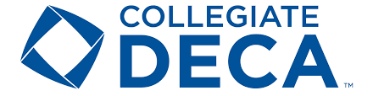

SAVE THE DATE

AUGUST - OCTOBER MEMBERSHIP REGISTRATION
SEPTEMBER 12 REGISTRATION AND HOUSING FOR EMERGING LEADERS SUMMIT DUE
OCTOBER 12 – 13 EMERGING LEADERS SUMMIT @ JOHNSON AND WALES UNIVERSITY IN MIAMI
NOVEMBER 8-10 ENGAGE (NEW YORK)
NOVEMBER 15 REGISTRATION DUE TO DECA INC.
DECEMBER 14 STATE CAREER DEVELOPMENT CONFERENCE REGISTRATION DUE
JANUARY 31 – STATE CAREER DEVELOPMENT CONFERENCE
FEBRUARY 2 HOSTED BY UCF/FULL SAIL UNIVERSITY
MARCH 8 INTERNATIONAL CAREER DEVELOPMENT CONFERENCE REGISTRATION DUE
MARCH 8 INTERNATIONAL CAREER DEVELOPMENT CONFERENCE HOUSING DUE TO TRAVEL VENTURES
APRIL 13-16 INTERNATIONAL CAREER DEVELOPMENT CONFERENCE ORLANDO, FL

**DATES ARE SUBJECT TO CHANGE

